Assumptions of Logistic Regression — Wisconsin Breast Cancer
Codecademy lab extended · short name: LogReg_Assumptions

Problem Statement
A tumour is labelled benign or malignant from ten “mean” nucleus measurements. Classes are uneven (357 B / 212 M) and a missed malignancy is far costlier than a false alarm. Before fitting a classifier we must check the logistic assumptions (binary target, independent rows, enough events per variable, no wild outliers, logit-linearity, no multicollinearity), then choose an operating threshold that puts recall first.

Solution Strategy
1) Encode M/B as 1/0 and confirm one row per id. 2) Cap features by the 10-EPV rule (212/10 = 21.2). 3) Screen outliers on log-z boxplots; drop fractal_dimension_mean above the 99th percentile. 4) Keep radius_mean and drop perimeter/area (r ≥ 0.99); note compactness–concavity (r ≈ 0.88). 5) Fit an unregularized 4-feature logit. 6) Sweep the decision threshold, draw the ROC, and compare default vs stratified vs class_weight='balanced'. 7) Stress-test with a Monte-Carlo on n, label noise and threshold.

Solution
Hold-out (random_state=0, 30%): accuracy ≈ 0.91, precision ≈ 0.85, recall ≈ 0.90, F1 ≈ 0.88, AUC ≈ 0.98. Confusion at t=0.50: TN 98 / FP 10 / FN 6 / TP 57. Lowering the cut to 0.25 cuts FN to 2 and raises FP to 14 — the clinical direction of travel. Dummy most-frequent AUC = 0.50.
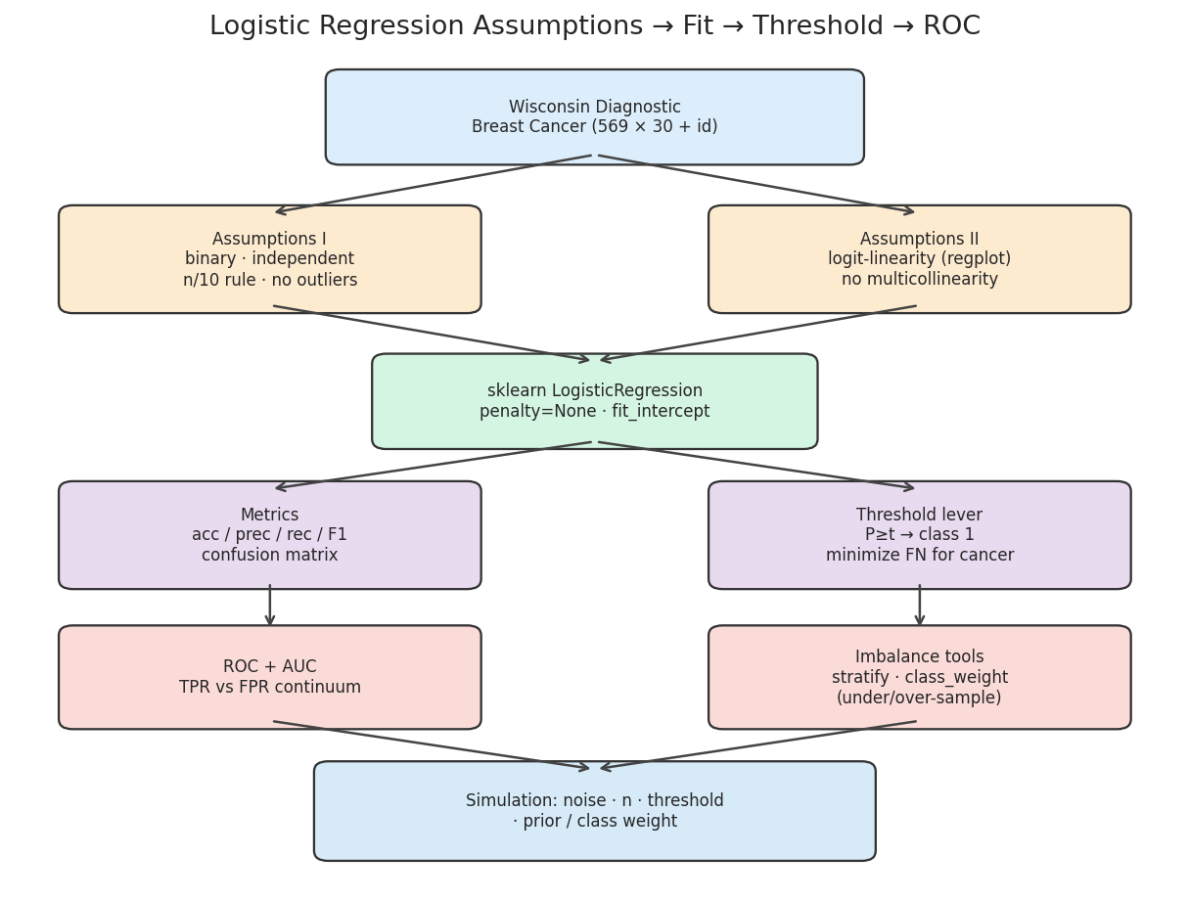
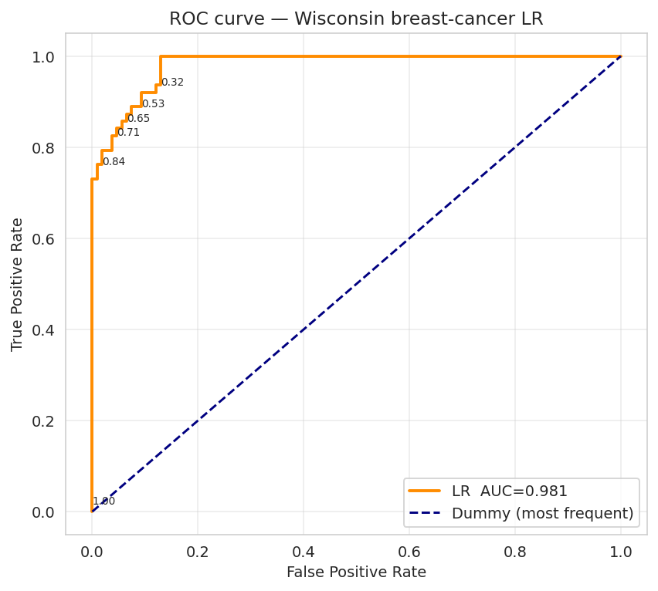
Left: workflow from assumption checks through threshold and imbalance tools. Right: ROC vs a most-frequent dummy; labelled thresholds sit along the curve. Sitting near t≈0.25 keeps TPR high at a moderate FPR.

Key Takeaways
- Assumption checks are not decoration: collinear size features and a heavy fractal tail would have distorted coefficients.
- Accuracy is the friendliest number and the least useful here — quote recall, FN count and AUC.
- t = 0.5 is a software default, not a clinical policy. Move it until the FN budget is met.
- class_weight='balanced' and stratified splits are cheap insurance when positivity ≠ 0.5.
- Do not use this procedure for repeated measures, <10 EPV, 3+ classes, or causal claims from observational features.

